**Energy Pricing Analysis Report**

**Introduction**

* This report provides a detailed analysis of energy pricing scenarios based on historical market data and predictive models.
* The aim is to assess the effectiveness of different pricing strategies --- Index-Based pricing and Variable Megawatts --- by evaluating potential profits and losses.
* Historical price trends, predictive models, and various pricing strategies are analyzed to ensure informed decision-making in energy trading.

1. **Historical Market Price Analysis**

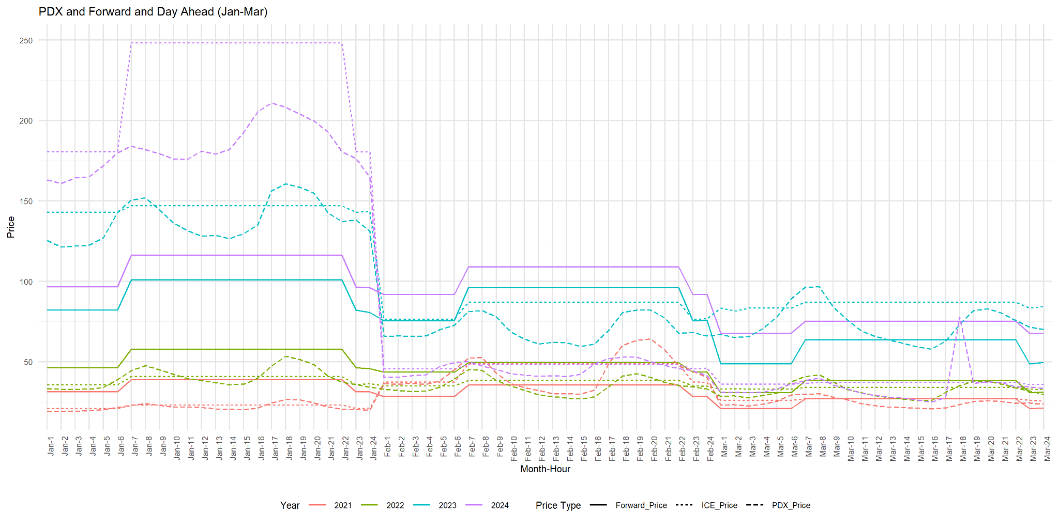

**Summary:**

* This graph compares PDX (real-time) prices, forward prices, and day-ahead prices from January to March over several years.
* The forward prices are generally higher than both PDX and day-ahead prices, reflecting the premium paid for securing future energy.

**Key Observations:**

* **January:**
  + **Observations**:
    - Prices in January start relatively low across all years but show a significant increase mid-month, especially in 2022 and 2023.
  + **Analysis**:
    - This could be due to higher heating demands post-holiday season or supply constraints.
    - PDX (real-time) prices show the highest volatility, indicating unpredictable market conditions or weather impacts.
* **February:**
  + **Observations:**
    - February sees the most significant price spikes, particularly around early and mid-month in 2022 - 2023.
  + **Analysis**:
    - The price spikes suggest high demand periods, possibly related to colder weather or other market constraints.
    - Forward prices are generally more stable, indicating that market participants expected these spikes and hedged against them.
* **March:**
  + **Observations**:
    - Prices tend to stabilize in Marh, with fewer dramatic spikes.
    - The forward prices for 2024 remain slightly higher, reflecting future expectations of price increases.
  + **Analysis:**
    - As winter demand eases, prices begin to normalize.
    - This suggests a seasonal trend where energy prices peak in the colder months and taper off as the season changes.

**Implications:**

* The graph underscores the value of forward contracts in mitigating exposure to real-time price volatility, especially during peak winter months.
* The spread between forward prices and day-ahead prices indicates that market participants expect price increases in the longer term, prompting them to lock in forward contracts.
* The relatively stable PDX and day-ahead prices suggest that short-term fluctuations are more manageable, allowing businesses to plan for immediate energy needs without significant pricing concerns.

1. **YoY change with base year 2020**

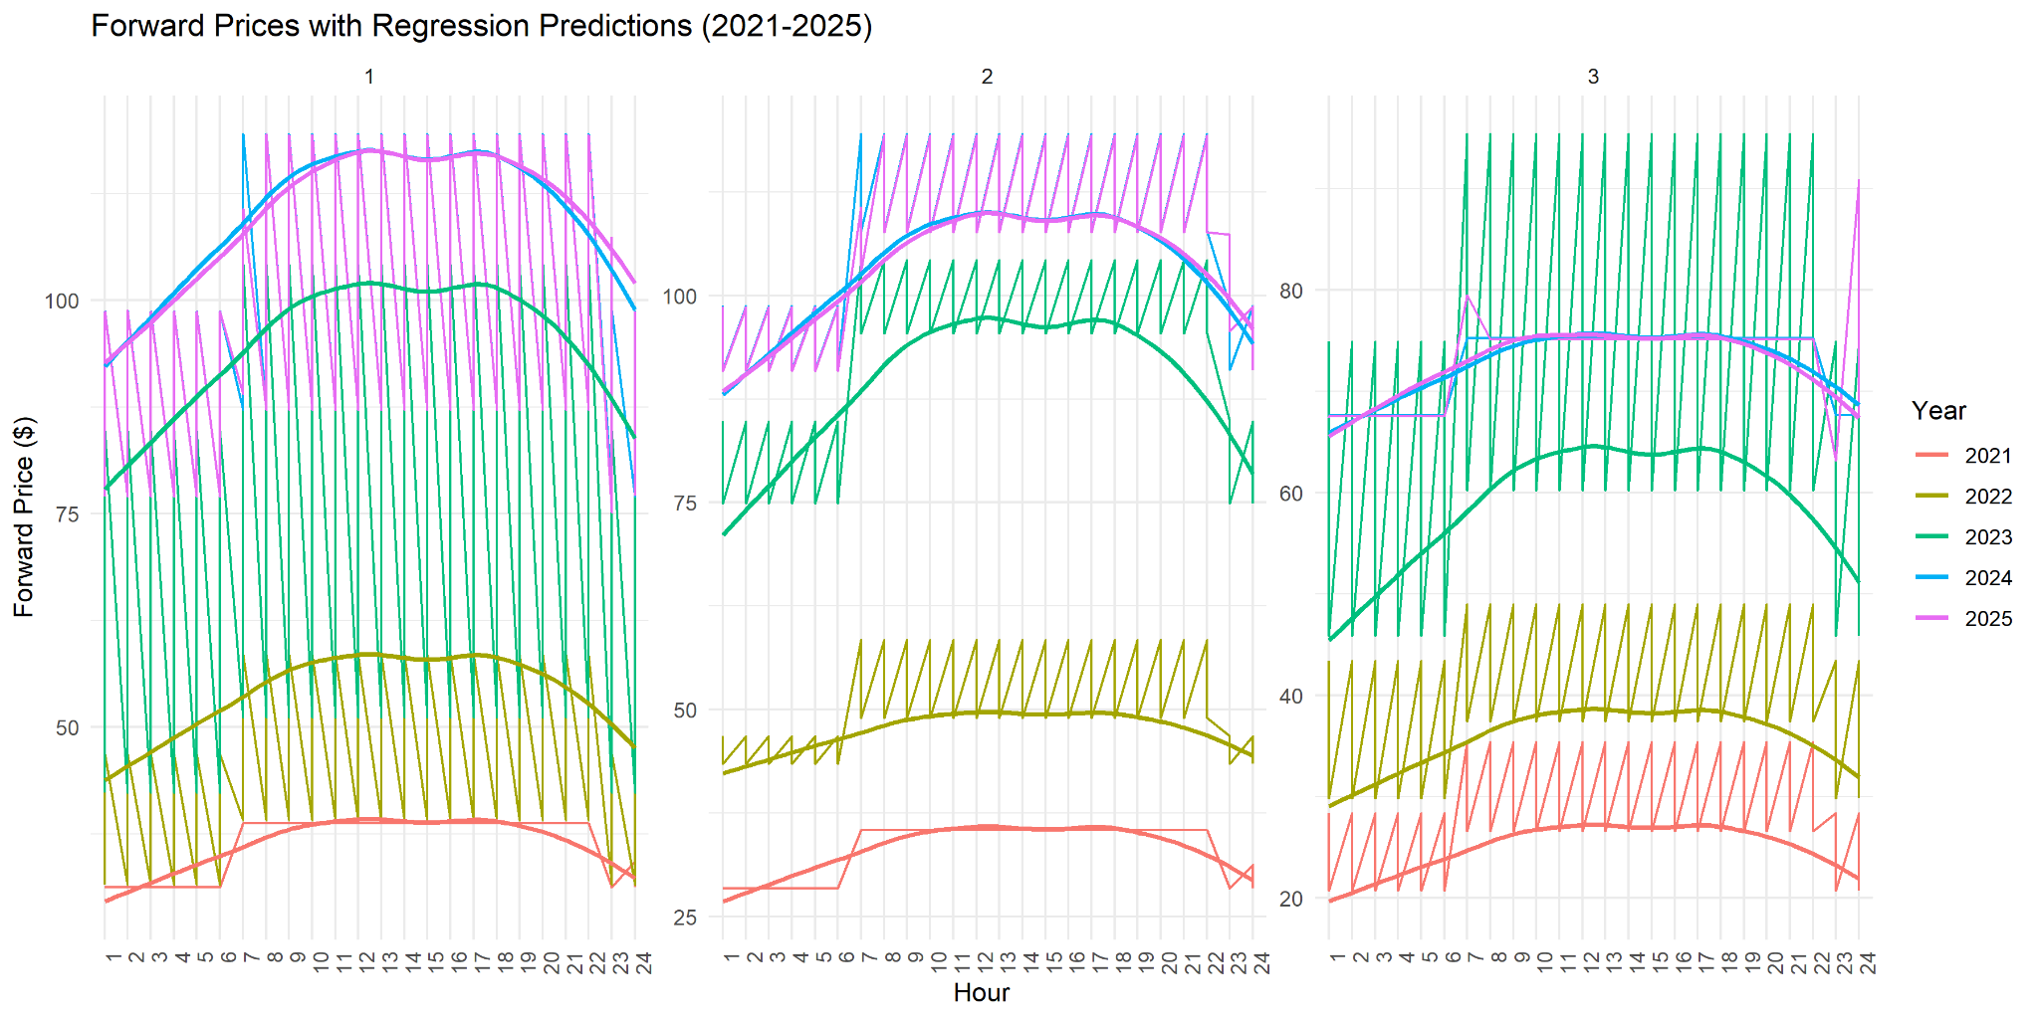

**Summary:**

* This graph illustrates the year-over-year percentage changes in PDX, Forward, and ICE market prices from January through March.
* The percentage change is calculated relative to a baseline year, presumably 2020.
* The graph shows trends for each market type, highlighting the fluctuations in energy prices over the selected months.

Key market types represented:

* PDX Price Percent Change **(dashed line)**
* Forward Price Percent Change **(solid line)**
* ICE Price Percent Change **(dotted line)**

**Key Observations:**

* **January:**
  + **PDX Prices**:
    - The PDX market shows significant volatility, with sharp increases at the beginning of January.
    - The percentage change hovers between 750% and 1000% for most of the month, reflecting substantial year-over-year price increases.
  + **Forward Prices**:
    - Forward market prices maintain relatively consistent year-over-year growth at around 500%.
    - This steady increase suggests more stable market conditions compared to the PDX market.
  + **ICE Prices**:
    - ICE prices also reflect high percentage changes, similar to PDX, although the volatility is slightly less pronounced.
    - The ICE market experiences an overall rise of 500-750% in January, indicating significant increases compared to previous years.
  + **Analysis:**
    - The high percentage changes across all markets in January suggest strong upward pressure on prices, driven by factors such as increased demand, supply constraints, or market disruptions.
    - This period indicates a challenging environment for energy buyers, as prices are significantly elevated compared to the baseline year.
* **February:**
  + **PDX Prices**:
    - A sharp drop in the PDX percentage change occurs towards the end of January and continues into February.
    - The prices stabilize at around 250% by mid-February and maintain this level throughout the month.
    - This decline suggests some normalization after the volatility in January.
  + **Forward Prices**:
    - Forward prices also decline but stabilize at a higher level than PDX, hovering around 500% year-over-year growth.
    - The forward market demonstrates resilience, maintaining higher year-over-year growth despite the reduction in volatility.
  + **ICE Prices**:
    - ICE prices follow a similar trend, with a decline in the first part of February and stabilization around 500%.
    - The year-over-year increase, while still significant, suggests that price levels are beginning to settle.
  + **Analysis:**
    - February shows a return to more stable market conditions after the extreme volatility in January.
    - The normalization in PDX and ICE markets may indicate improved supply conditions or reduced demand.
    - However, the persistence of elevated forward prices suggests that market participants still expect higher prices in the future.
* **March:**
  + **PDX Prices**:
    - The PDX market remains relatively stable throughout March, with percentage changes stabilizing around 250-500%.
    - There is a slight increase mid-month but overall, the volatility is much lower compared to January.
  + **Forward Prices**:
    - Forward prices continue to show steady growth at around 500%, reflecting the market’s ongoing expectation of higher prices.
    - The forward market’s stability in March suggests confidence in future pricing.
  + **ICE Prices**:
    - ICE prices follow a similar trend to PDX, with stabilization in March.
    - The percentage change remains elevated but shows much less volatility than earlier in the year.
  + **Analysis:**
    - March continues the trend of stabilization seen in February, with markets maintaining higher year-over-year growth but without the wild fluctuations observed in January.
    - The steadiness of forward prices indicates market participants' anticipation of sustained higher prices in the future.

**Implications:**

* **Market Volatility**:
  + January exhibits significant volatility across all markets, suggesting potential external shocks, such as unexpected demand spikes or supply chain issues, driving prices up dramatically.
  + These conditions may pose risks for energy market participants.
* **Stabilization in February and March**:
  + The gradual stabilization in February and March suggests a return to more predictable market conditions.
  + However, the persistently high forward prices indicate that market participants remain cautious and expect sustained price increases.
* **Strategic Considerations**:
  + Energy buyers and sellers need to account for this volatility when planning procurement or hedging strategies.
  + The elevated forward prices signal an opportunity for those willing to lock in rates early, but also a risk of overcommitting if prices stabilize further.

1. **Regression and Percent Change Models for 2025**

**Regression Model:**



**Summary:**

* This graph provides a predictive view of forward prices using regression analysis, highlighting the anticipated market trends through 2025.

**Key Observations:**

* **January:**
  + **Observations:**
    - January forward prices show an upward trend across the years, with the regression line predicting continued growth into 2025.
    - The forward prices show a clear pattern of higher prices during the mid-day to early evening hours (around 10 AM to 8 PM), with the peak occurring around midday (12 PM to 3 PM) across all years (2021-2025).
    - Nighttime and early morning hours (12 AM to 6 AM) exhibit significantly lower prices, which is consistent across all years.
    - Notably, prices in 2024 and 2025 are higher across most hours compared to previous years, indicating an upward shift in expected energy demand and costs.
  + **Analysis:**
    - The higher prices during daytime hours suggest increased energy demand during work hours, potentially driven by commercial and industrial activities.
    - Companies with flexible operations might reduce costs by shifting energy-intensive activities to early morning or late-night hours.
    - The upward trend in 2024 and 2025 suggests a need for forward contracts or other hedging strategies, especially for businesses that rely heavily on energy during peak hours.
* **February:**
  + **Observations**:
    - The pattern in February is similar to January, with forward prices peaking during the day (10 AM to 8 PM) and dropping during nighttime and early morning hours.
    - The highest prices are again seen around midday, but the overall price levels are slightly lower than in January.
    - The trends for 2024 and 2025 still indicate an increase in forward prices compared to earlier years, though the peak is not as pronounced as in January.
  + **Analysis**:
    - While February prices are slightly lower than January, the same strategy of shifting energy usage to off-peak hours can still provide cost savings.
    - The data suggests that companies should remain cautious and continue to monitor price movements, especially in preparation for potential increases in March.
* **March:**
  + **Observations**:
    - In March, forward prices continue to show the same daily cycle of peaks during the day and dips during nighttime hours.
    - However, the price spikes are not as extreme as in the earlier months, indicating a gradual normalization in the market.
    - Prices in 2024 and 2025 remain higher than in 2021-2023, but the differences are less pronounced than in January and February.
  + **Analysis:**
    - March presents a more stable pricing environment, with less volatility than January or February.
    - This could be an opportunity for businesses to secure energy at more predictable rates, especially if they have held off on locking in contracts earlier in the year.
    - Continued monitoring of forward prices will be essential as the year progresses, especially considering the upcoming summer price spikes seen in previous years.

**Implications:**

* The upward trend suggests continued price pressures, reinforcing the importance of strategic planning and market timing.
* **Daytime Hours (10 AM - 8 PM)** consistently exhibit the highest forward prices across all three months, with peaks occurring around midday.
* **Nighttime and Early Morning Hours (12 AM - 6 AM)** offer the lowest prices, suggesting opportunities for cost savings through strategic energy usage during these times.
* **2024 and 2025** prices are consistently higher across all months and hours compared to earlier years, reflecting increased expectations of energy costs in the near future.

**Overall Insights and Recommendations:**

* **Rising Costs:**
  + Across all graphs, a consistent upward trend in prices signals increasing market costs, urging participants to explore cost management strategies such as renewable energy investments or enhanced energy efficiency measures.
* **Predictive Utility:**
  + The regression and percent change models provide valuable foresight, aiding stakeholders in making informed decisions to mitigate risk and capitalize on pricing trends.
* **Peak Management:**
  + Persistent peak pricing during midday hours emphasizes the need for effective demand management, including energy storage or demand response initiatives.

1. **Index-Based Pricing Scenario**

**Objective:**

* To compare the revenue from selling energy based on an index plus a premium with the cost of buying back energy at market index prices and ensure that the scenario results in zero or positive profit.

**Data (Example Scenario w/ Real Data):**

* Energy Sold: 40 MW/hr for 4 hours = 160 MWh
* Energy Purchased Back: 10 MW/hour for 16 hours = 160 MWh
* Historical Prices Used:
  + January HE 19-22 Mean Index Price → $116.37
  + February HE 19-22 Mean Index Price → $108.97
  + March HE 19-22 Mean Index Price → $75.25

**Calculations:**

* **January:**
  + Sell Price: $116.37 + $90 (premium) = $206.37/MWh
  + Buy Price: $116.37/MWh
  + Revenue from Selling: 160 MWh x 206.37 $/MWh = $33,019.20
  + Cost of Buying Back: 160 MWh x 116.37 $/MWh = $18,619.20
  + Profit: $33,019.20 - $18,619.20 = $14,400
* **February:**
  + Sell Price: $108.97 + $90 (premium) = $198.97/MWh
  + Buy Price: $108.97/MWh
  + Revenue from Selling: 160 MWh x 198.97 $/MWh = $31,834.40
  + Cost of Buying Back: 160 MWh x 108.97 $/MWh = $17,435.20
  + Profit: $31,834.40 - $17,435.20 = $14,399.20
* **March:**
  + Sell Price: $75.25 + $90 (premium) = $165.25/MWh
  + Buy Price: $75.25/MWh
  + Revenue from Selling: 160 MWh x 165.25 $/MWh = $26,440.00
  + Cost of Buying Back: 160 MWh x 75.25 $/MWh = $12,040.00
  + Profit: $26,440.00 - $12,040.00 = $14,400.00

**Analysis:**

* In the Index-Based scenario, selling energy at a price based on the market index plus a premium and purchasing back at the market index price yields consistent positive profits across all three months.
* The profit margins are robust, suggesting that this strategy is effective on a large scale in leveraging high market prices for revenue generation while maintaining manageable buyback costs.

1. **Variable Megawatts Scenario**

**Objective:**

* To sell energy at a higher price and purchase back at a lower price, adjusting the amount of energy purchased back to ensure zero or positive profit.

**Data (Example Scenario w/ Real Data):**

* Energy Sold: 40 MW/hr for 4 hours = 160 MWh
* Energy Purchased Back: Variable
* Historical Prices Used:
  + January HE 19-22 Mean Index Price → $116.37
  + February HE 19-22 Mean Index Price → $108.97
  + March HE 19-22 Mean Index Price → $75.25

**Calculations:**

* **January:**
  + Selling Price (HE 19-22 Mean Price) = $116.37/MWh
  + Buy Price (HE 07-22 Mean Price) = $96.65/MWh
  + Revenue: 240 MWh x 116.37 $/MWh = $27,924.80
  + Cost of Buying Back for Zero Profit = $27,924.80
  + Energy Purchased Back: ($27,924.80 / 96.65 $/MWh) = 289.5 MWh
  + Adjusted Energy Purchased Back:
    - Cost: 240 MWh x 96.65 $/MWh = $23,316.00
    - Profit: $27,924.80 - $23,316.00 = $4,608.80
* **February:**
  + Selling Price (HE 19-22 Mean Price) = $108.97/MWh
  + Buy Price (HE 07-22 Mean Price) = $91.80/MWh
  + Revenue: 240 MWh x 108.97 $/MWh = $26,153.80
  + Cost of Buying Back for Zero Profit = $26,153.80
  + Energy Purchased Back: ($26,153.80 / 91.80 $/MWh) = 285.1 MWh
  + Adjusted Energy Purchased Back:
    - Cost: 240 MWh x 91.80 $/MWh = $22,032.00
    - Profit: $26,153.80 - $22,032.00 = $4,121.80
* **March:**
  + Selling Price (HE 19-22 Mean Price) = $75.25/MWh
  + Buy Price (HE 07-22 Mean Price) = $67.65/MWh
  + Revenue: 240 MWh x 75.25 $/MWh = $18,060.00
  + Cost of Buying Back for Zero Profit = $18,060.00
  + Energy Purchased Back: ($18,060.00 / 67.65 $/MWh) = 267 MWh
  + Adjusted Energy Purchased Back:
    - Cost: 240 MWh x 67.65 $/MWh = $16,236.00
    - Profit: $18,060.00 - $16,236.00 = $1,824.00

**Analysis:**

* In the Variable Megawatts scenario, selling energy at a higher price and purchasing back at a lower price yields positive profits, although the margins are narrower compared to the Index-Based Pricing scenario.
* Adjusting the amount of energy purchased back ensures that profits are maintained, but the profitability decreases as the energy purchased back increases.

1. **Conclusion**

* The analysis of various energy pricing scenarios reveals valuable insights into potential profit strategies.
* The Index-Based Pricing scenario consistently yields substantial profits across different months, indicating its effectiveness in leveraging high market prices.
* The Variable Megawatts scenario also shows positive profits but with narrower margins, emphasizing the need for careful adjustment of buyback amounts to ensure profitability.
* By understanding historical trends, predictive models, and different pricing strategies, stakeholders can make more informed decisions and optimize their energy trading strategies to maximize returns and mitigate risks.